Git Commands and Their Meaning

1. Introduction to Git

What is Git?
Git is a distributed version control system used to track changes in files, manage different versions of a project, and collaborate with other developers.

What is GitHub?
GitHub is an online platform that stores Git repositories and allows developers to share and collaborate on projects.

git --version
Purpose:
Checks the installed Git version.
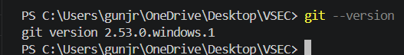

git config --global user.name "Your Name"
Purpose:
Sets the username for Git commits.

git config --global user.email "your@email.com"
Purpose:
Sets the email address associated with Git commits.

git init
Purpose:
Creates a new Git repository in the current folder.

git status
Purpose:
Shows the current state of files.
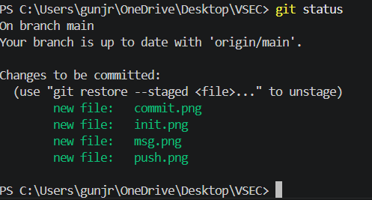

git add filename
Purpose:
Adds a specific file to the staging area.

git commit -m "message"
Purpose:
Saves changes permanently with a description.
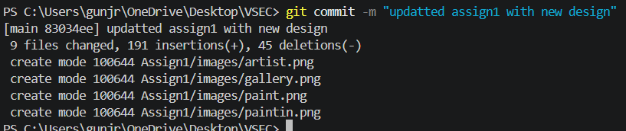

git remote add origin URL
Purpose:
Connects local repository with a GitHub repository.

git remote -v
Purpose:
Displays connected remote repositories.

git remote remove origin
Purpose:
Removes the connection with a remote repository.

git push
Purpose:
Uploads committed changes to GitHub.

git push -u origin main
Purpose:
First-time push and connects local branch with remote branch.
